Lab 1

Introduction to Logic Circuit

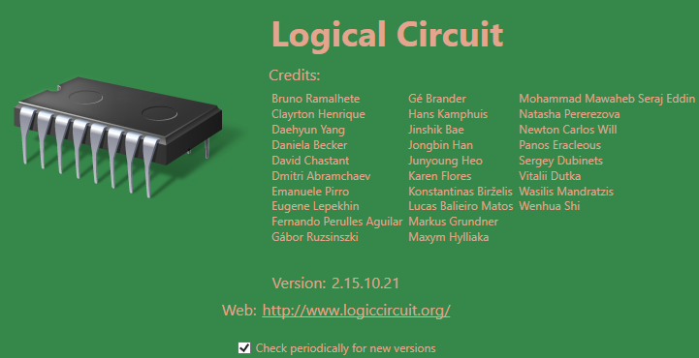
Welcome to Logic Circuit. Logic Circuit (LC) is a logic simulator. With Logic Circuit you can create anything from simple to complex digital circuits. This is a tutorial introduction. Once the tutorial is complete you should be able to implement basic digital circuits.
Part 1
1). Start Logic Circuit, go to the window start menu, type “Logic Circuit”, it should show up.
2). The Interface may be a little daunting at first, the File and Edit menus works like all others. Although Logic Circuit is stable, save and save often. By default it will open the last project you had open. Start a new Project, File -> new.
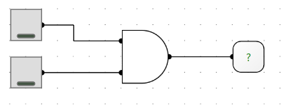
3). Learn by doing. Let us create a circuit to view the operation of a basic AND Gate. We will create the circuit shown to the right. From the left menu select a 2 input and gate. You will notice that you can alter the number of inputs of the gate.
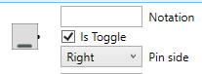
4). We provide the “input” to the gate with buttons (switches), find it on the menu, set it to toggle as in the picture to the right.
5). Output of a gate is read using probes. Find the probe on the menu and create one to monitor the output of the AND gate.
6). To Run the circuit, we must supply power to it, on the bottom right you will find . Toggle this button, it will turn RED indicating the circuit (cct.) is powered. At this point you may play with the buttons and experience an AND gate. When you are finished turn of the power button; you will the go back into editing mode.
Part 2.
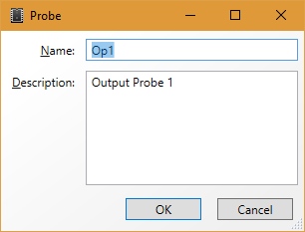
1). Let us clean up the circuit by providing some additional information to the inputs and outputs. In fact what you are about to do will be required as part of any assignment using Logic Circuit. Double click the probe, a text box will appear, name the probe and provide a useful description as in the example to the right.
2). Similarly, provide names and descriptions for the inputs.
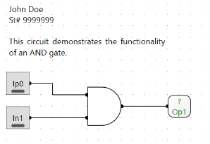
3). Each circuit which you submit will require your name and student number to be added. As well as a short description of the circuit. This serves as documentation. Much like documenting code. From the left menu click on once, hold and drag a text box to your circuit. Create a description similar to the example to the right.
Part 3
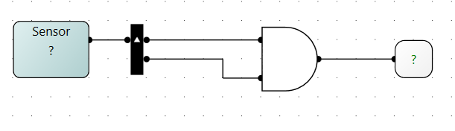
1). Improvements can be made, often having a button for each input is tedious, and consumes space. Replace the buttons with a sensor input, the sensor will be 2 bits wide, that is, the output of the sensor will have a buss width of 2 bits. These need to be split apart into single bits to provide the individual inputs to the AND gate. We use a splitter (or combiner) as shown above. Notice the little white arrow. This indicates pin 0, or in our case bit 0 is on top. This is important when you create larger circuits, not taking this into account can mean entire busses will be wired backwards.
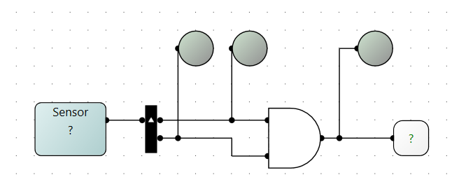
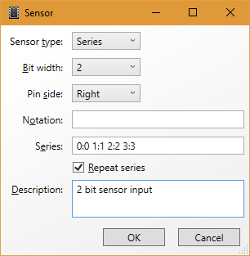
2). The sensor can be set to several modes. Commonly we would use manual, which will require us to type into the sensor what signals we want to test the circuit with. 2 bits will provide 4 possible outcomes, in this case we can set the sensor to series, and provide what the series is. Double click the sensor and set it as in the graphic to the right. Run the circuit and observe what happens.
3). Add 3 LEDs to view the signal within the wire. Run the circuit.

Part 4
1). Generating Truth Tables is important for any logical circuit. Logic circuit does this by cycling all possible inputs to a circuit and then recording the output. To simplify things, modify your circuit as below. When selecting the input be sure to set it as 2 bits, you can alternately have 2, 1 bit inputs, labelled A and B. Try Both
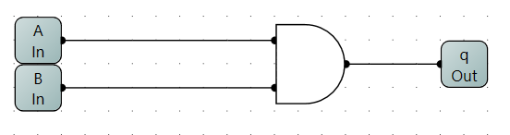
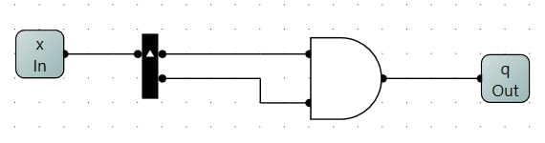

2). From the Circuit Menu at the top select Truth Table.
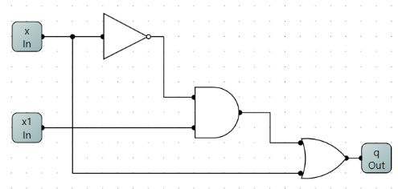
Part 5.
1). You’re on your own now, implement the following, and generate the Truth table. Remove the input and outputs and replace these with sensors and probes. Play with it.
2). Implement the following truth table in Logic Circuit. Draw the circuit. Use sensor inputs and a probe for the output. What function does this circuit implement?
A | B | C | OP
0 | 0 | 0 | 0
0 | 0 | 1 | 0
0 | 1 | 0 | 0
0 | 1 | 1 | 1
1 | 0 | 0 | 0
1 | 0 | 1 | 1
1 | 1 | 0 | 1
1 | 1 | 1 | 1

