COSC 1P03 – Assignment Submission Guide

So, you want to submit your assignment, but you don't know where to start, right?
“How do I submit electronically? Where do I hand in the printouts? Why is Earl so awesome?”
I can help you with two of those questions! (The last deals with magnitudes of profundity still outside the bounds of modern science)

Electronic Submission:
First things first, go to J310 or J301.
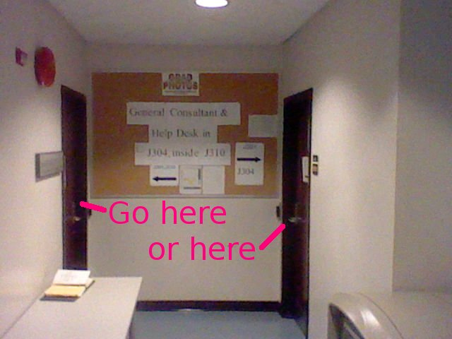

Log into one of the lab computers.
Open up “My Computer”. Open your Z: Drive.
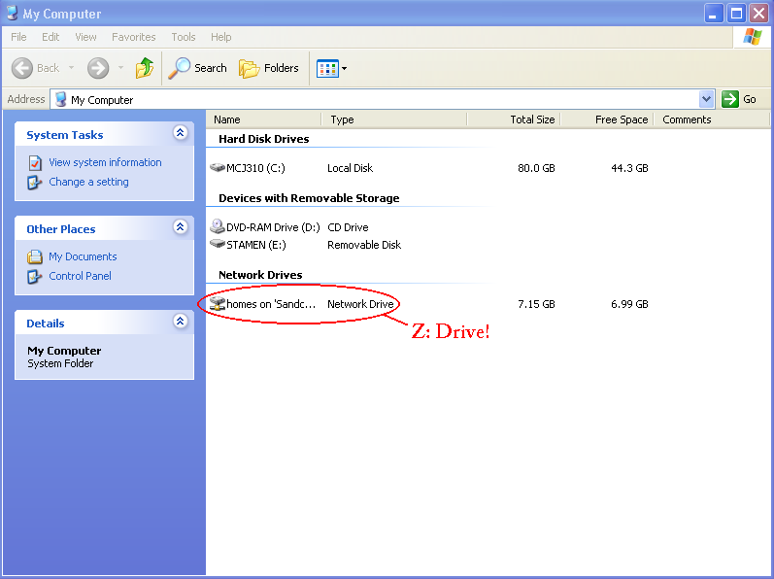

Make a folder for 1P03.
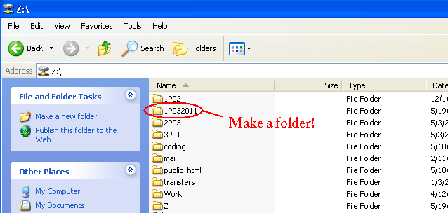

Enter your 1P03 folder, and create a folder for this assignment inside it.
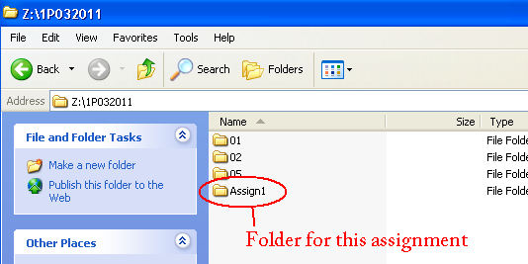

Open this folder, and drop your files into it.
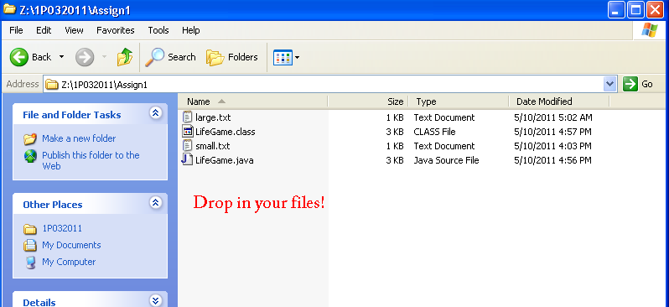

You're done with this window, so you can close it.

Next, open PuTTY (in the Start menu).
Enter sandcastle.cosc.brocku.ca as the Host Name, and then click Open.
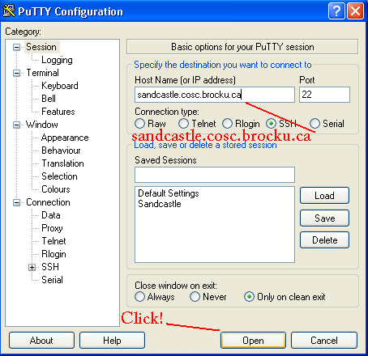

Log into sandcastle, using the same login as you used for the lab computer.
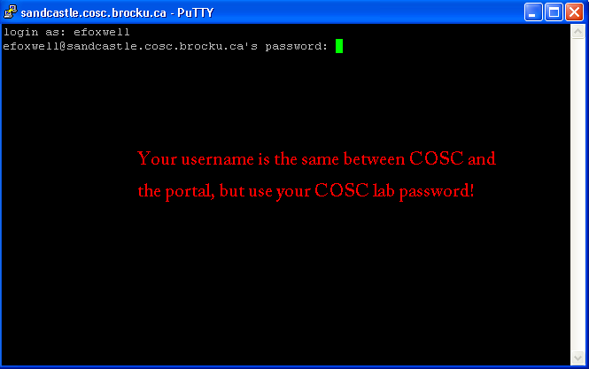

You're in your home folder. It may seem different, but this is the same as your Z: Drive in windows.
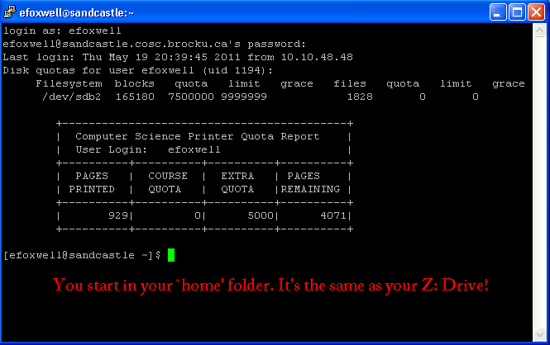

You now need to navigate to the folder that contains your files.
Important 'nix commands:
cd {folder name} Change directory to {folder name}
ls Display current directory's contents
cd .. Change to parent directory
exit We're done!
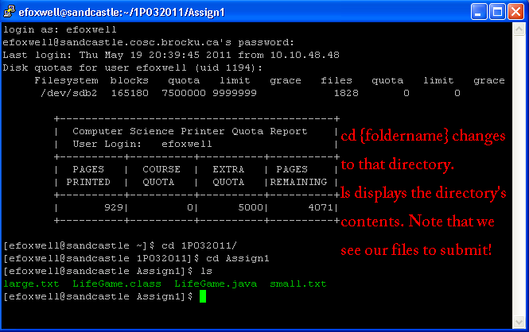

After you've confirmed that your files are there, it's time to submit!
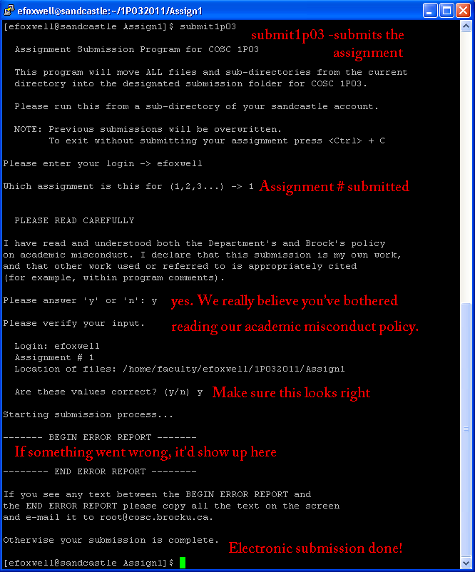
Electronic Submission Complete!

Physical Submission:
First, of course, you need to print out your source code and a sample execution (see the assignment specification). If it's too thick to staple together, you'll need a 9x12” envelope (the CSC sells them, as does the book store).
Stapled to the front of the assignment (the printout, or the envelope if you're using one) needs to be a Departmental Cover Page.
Go to the COSC homepage. Click on Undergraduate Students.
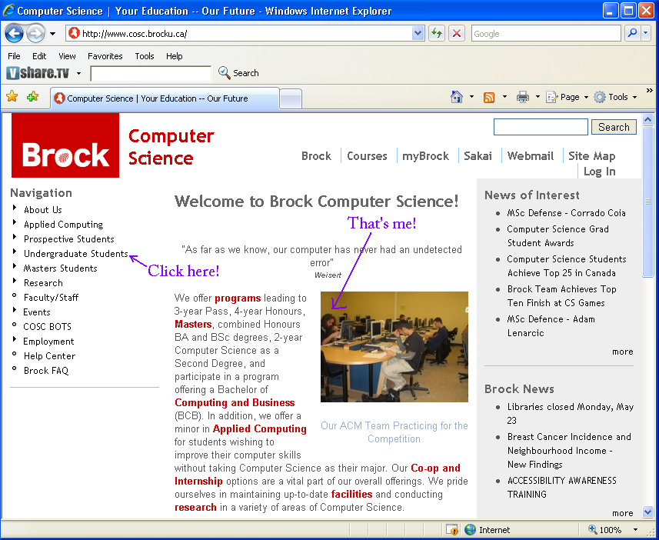

At the left, you should see a link that says Cover Page. Click it.
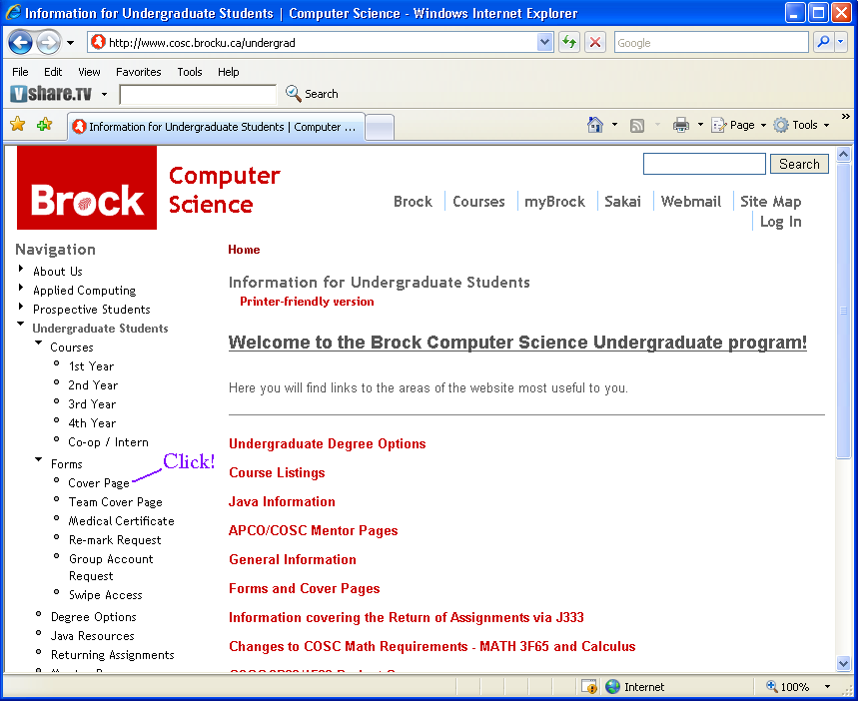

It's incredibly important that you enter your Student Number correctly. (That's the point of the cover page in the first place!) After you've entered it, click Generate Cover Page.
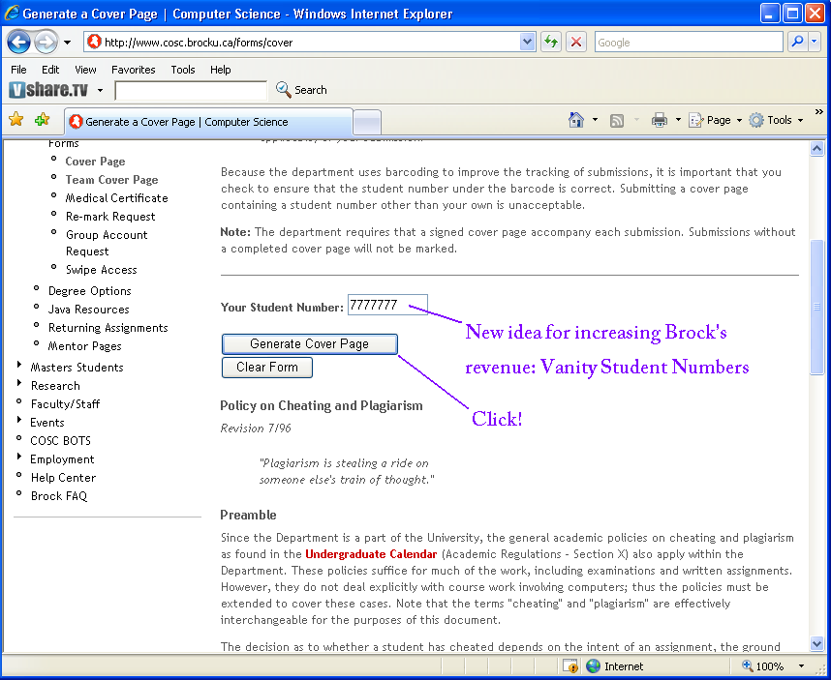

You should now see an automagically-generated cover page, complete with your Student Number and a barcode that identifies you. Print it out! (This is what you'll be stapling to the front of your assignment)
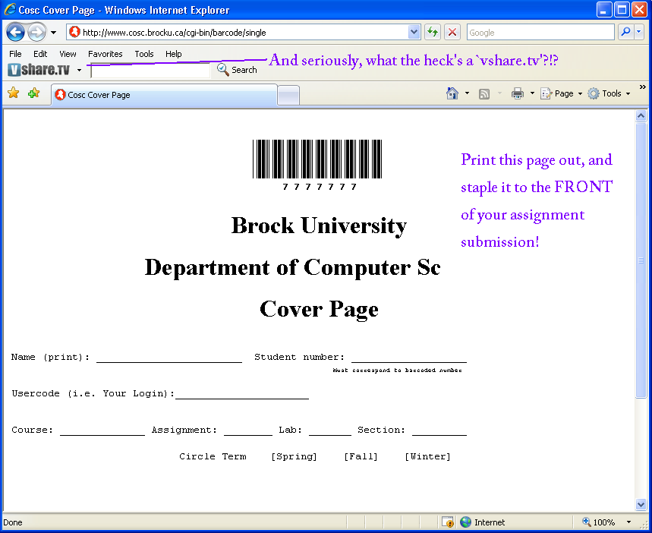

Once everything's assembled, all you need to do is drop it into the course's dropbox!
They're pretty easy to spot in the department.
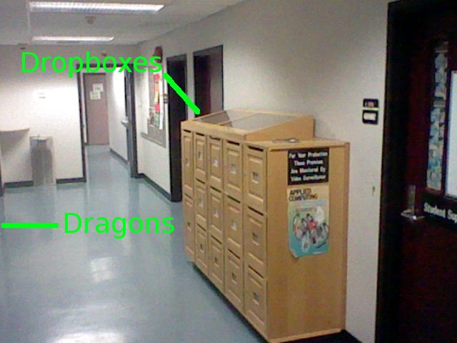

Find the one labelled COSC 1P03 and drop it in!
